Business Sales Performance Analytics Report

Executive Summary
Total Sales: $2,297,200.86
Total Profit: $286,397.02
Total Orders: 5009
Top Performing Category: Technology
Top Performing Region: West
Top Customer Segment: Consumer

Key Insights
- The Technology category generated the highest sales revenue.
- The West region contributed the largest share of sales.
- The Consumer customer segment produced the strongest sales performance.
- Some products generated high sales but low profit, indicating possible discount inefficiencies.
- Monthly sales trends indicate seasonal fluctuations that can guide inventory planning.

Visualizations
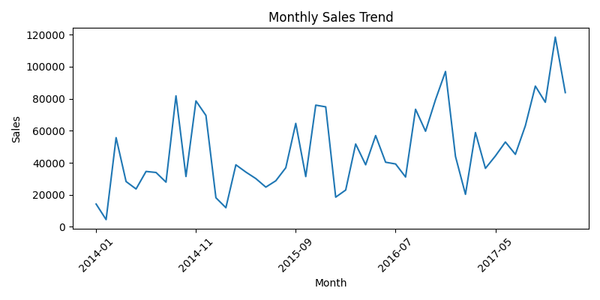

Business Recommendations
- Increase marketing focus on high-performing categories and regions.
- Review discount strategies on low-profit products.
- Optimize inventory during peak sales months.
- Target profitable customer segments with loyalty programs.
- Use predictive analytics models to forecast future sales and profit.

